Core-Course Worksheet
Review the core-course worksheet instructions prior to completing this form. Once complete, return this Core-Course Worksheet to ec-processing@ncaa.org. Failure to fill out this worksheet correctly will result in the submission not being reviewed.
Student Name: NCAA ID:
Course Name: Grade/Year Taken:
Please select the subject area for which this course receives graduation credit:

q English.
q Math.
q Science.
q Social Science.
q World Language.
q Comparative Religion.
q Philosophy.

Teacher of Record: Other Teacher:
Grade Based On (NOT a request for a grading scale; please read instructions):

Prerequisite(s):

Text(s) Used:

Curriculum Provider/Designer:
Course Description:
Course Content/Goals/Outline:

Types of Assessments Used:

Assessments Designed/Developed By:
Assignments Graded By:
Grade Achieved: Credit Awarded:
By submitting this information to the NCAA Eligibility Center, as the home school administrator I verify that the information is complete and accurate. I verify that I have reviewed and approved the information. The responses I am providing for the purposes of this review are considered my school/program’s full and final submission.
Printed Name: Date (mm/dd/yyyy):
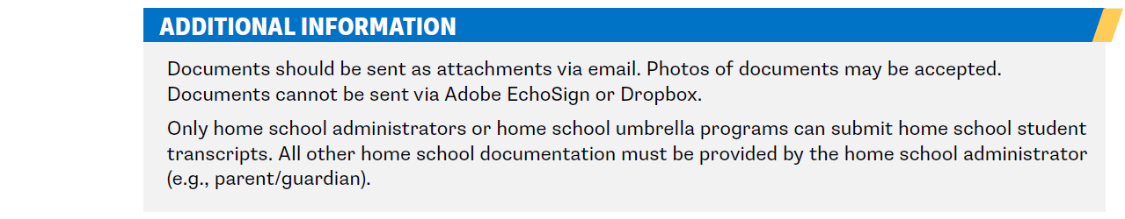
Parent/Guardian Signature:

